First Requirement :

I have implemented 2 solutions for first requirement.

1. In first implementation I have created a checkbox field ‘Send Survey’ on Contact. In the batch class I am fetching all the contacts where survey date <= today. And in the execute method of batch class I am making ‘survey date’ field as null and ‘send survey’ as true. This will trigger the workflow and it will send email alert to those contacts. In the same workflow I am making ‘send survey’ as false again once email is sent.

This implementation will not count the emails sent through workflow against daily single email message limit.

In this scenario we had only 2 languages so I have created 2 workflows one for each language German and English.

**If there are multiple languages then we can go for process builder. In single process builder we can have multiple email alerts for multiple languages.**

1. In this implementation I am sending emails though batch class only. In this I am fetching the email templates first for different languages. And then send creating singleemailmessages on based of the contact language and email template.

For keeping the limit in mind I am using the method Messaging.reserveSingleEmailCapacity(count) which will throw exception if the count of emails I am sending breach the daily email limit(where count will be the number of emails I am sending in that batch). This will not allow updating the ‘survey date’ field to null as the above method already thrown exception and code will go in the catch block.

Components :

1. EmailTemplate
   1. English_Survey_Template – Email Template for English Email.
   2. German_Survey_Template – Email Template for German Email.
2. Workflows
   1. Send_English_Email_on_Survey_Date – to trigger English email alert and mark ‘send survey’ back to false
   2. Send_German_Email_on_Survey_Date - to trigger German email alert and mark ‘send survey’ back to false
3. Classes
   1. SendAutoSurveyWithApexBatch - to send email through apex and set the ‘survey date’ to null
   2. SendAutoSurveyWithApexScheduler – to schedule the above class.
   3. SendAutoSurveyWithWorkflowBatch - to mark ‘send survey’ as true and set the ‘survey date’ to null and send email through workflow which will not count in daily single message limit
   4. SendAutoSurveyWithWorkflowScheduler – to schedule the above class.

Second Requirement :

For this requirement I have created a lightning component ‘ProductInfoPage’ with Controller Apex Class ‘ProductInfoCtrl’. I am displaying the Lightning component on Case Layout. I have created a separate button ‘Refresh’ on the component so that if user is on the case page for some time and the data is changed from backend then user can click on refresh button to check the current details about the cost of product.

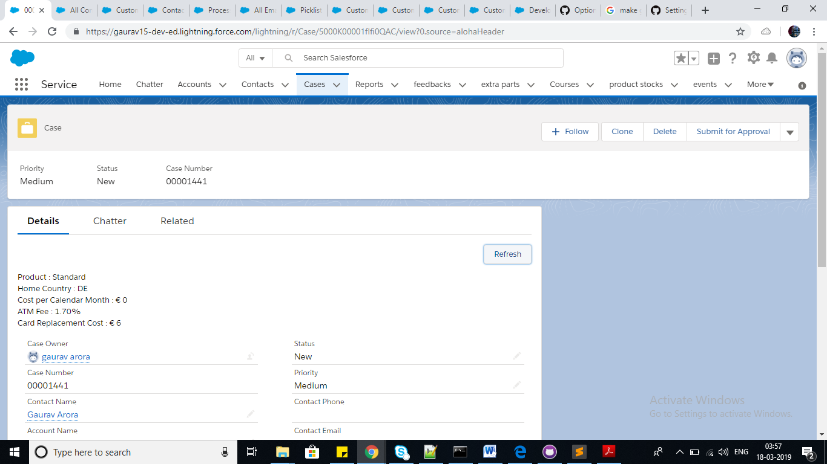

In this I am saving the product data provided in the requirement pdf in Custom Settings.

**We can do automatic refresh also if data is changed from backend then user don’t need to refresh manually. For that we need to use streaming API or Platform Events.**

Components :

1. AuraComponent
   1. ProductInfoPage – to display the product information.
2. Classes
   1. ProductInfoCtrl – to fetch the product cost related data from the custom settings
3. Flexipage
   1. Case_Record_Page – to embed the lightning component on case layout.
4. Custom Settings
   1. ATMFeeInOtherCurrencies__c – to store the ATM Fee for different products in different countries
   2. CardReplacementCost__c - to store the Card Replacement Cost for different products in different countries
   3. CostPerCalendarMonth__c - to store the Cost per Month for different products in different countries

Rest I have uploaded Object files, labels and layout files which is used in the implementation.